**Why use GCSEPod?**

**It’s convenient and effective**

The Pods can be downloaded on any device so your child can watch them **online or offline**. Wherever they go, GCSEPod goes with them. It’s like they’re carrying an **entire world of knowledge** **and revision in their pocket.**

An **expert reads and explains everything** clearly and precisely with all the right **facts, quotes, keyword and annotated diagrams** on screen.

Your child won’t need to use GCSEPod for long before they feel the impact. **Consistent use in just 10 minute chunks is proven to support achievement right up to a grade 9.**

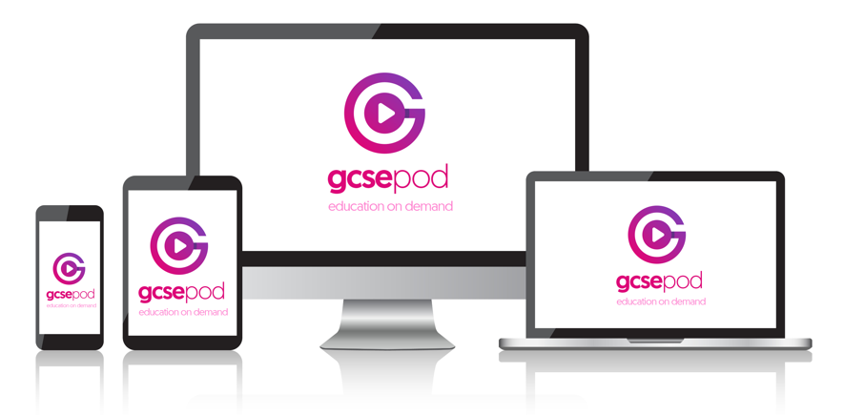

**What is it?**

* One **website**, **3 apps** and over **6000 Pods.**
* Content produced specifically for mobile **devices, tablets** and **PCs.**
* Designed to squeeze exactly the right knowledge needed for **exam success** into short **3-5 minute chunks.**
* Helps with **learning, homework** and **revision.**

**It will help your child get organised**

Your child can create personal playlists to listen to in the run-up to an exam, to help with homework or on the go to help consolidate learning.

The viewing history feature enables your child to return to Pods they found useful. There’s also a ‘Favourites’ playlist, which enables them to easily return to Pods on areas they may be finding difficult.

Premade exam specific playlists, available in the ‘My Courses’ area are neatly organised meaning your child can manage revision quickly and easily whilst prioritising their time.

**It can be as discreet (or loud) as they want**

Your child can listen to Pods anywhere and everywhere and because it looks like they’re listening to music, no one needs to know they’re actually swotting up.

Your child may want to show off just how much work they’ve been doing or even recommend a Pod to a friend, to do this, they can use the social networking links on the site to connect with others.

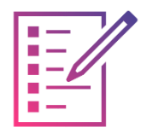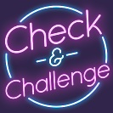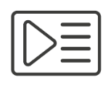

**Paper to Pod Guides**

Your child can use our guides alongside their marked past exam papers to identify areas they need to focus on. They can watch the Pods relating to questions they didn’t do so well on to help fill any knowledge gaps.

**Assignments**

View homework set by your child’s teacher. Your child should watch Pods selected by their teacher and complete the questions to help test their knowledge.

**Downloads**

You can download all our Pods to your child’s mobile device so they can learn on the go, anywhere they are. There are 3 GCSEPod apps which are free to download.

**My Courses**

Your child can keep organised by viewing a list of their upcoming exams in subject or date order. They can view an exam playlist to see all the Pods relevant to that exam.

**Playlists**

Your child can create their very own bespoke playlist by selecting Pods that they feel they need to focus on. They can then watch the playlist to brush up on their knowledge or download it to take it everywhere they go.

Check & Challenge

Your child can test their knowledge on Pods by completing quizzes and questions. They will receive instant feedback on their answers with helpful tips to help them understand why it’s right or wrong.

*\**If you’re having trouble finding your school, double check that you’ve entered the correct date of birth and full name as it appears on the school’s register. Some schools are known by a shorter version of their name so make sure you’re typing the full, official school name.

**How does your child get it?**

Your child has already been registered by their school and simply needs to activate their account. To help your child activate their account, follow these simple steps:

1. Go to [www.gcsepod.com](http://www.gcsepod.com) and click “Login”
2. Click “New Here? Get Started!” and select “Student”
3. Enter your child’s name, date of birth and type in the name of their school. The school’s name should appear. Click on it to confirm.
4. Create a username and password

**Key Features**

**Quick Start Guide**